EXPERIMENT 10

10.1.1//Remove punctuation from a string
Ans: ALGORITHM:
Step 1: Start
Step 2: Initialize an empty string
str ← ""
Step 3: Read the input string
Read s
Step 4: For each character i in string s
Step 5: Check if the character is alphanumeric OR space
If i.isalnum() OR i.isspace()
Step 6: If condition is true, append character to string
str ← str + i
Step 7: Repeat Steps 4–6 until all characters are checked
Step 8: Print the string str
Step 9: Stop
FLOWCHART:
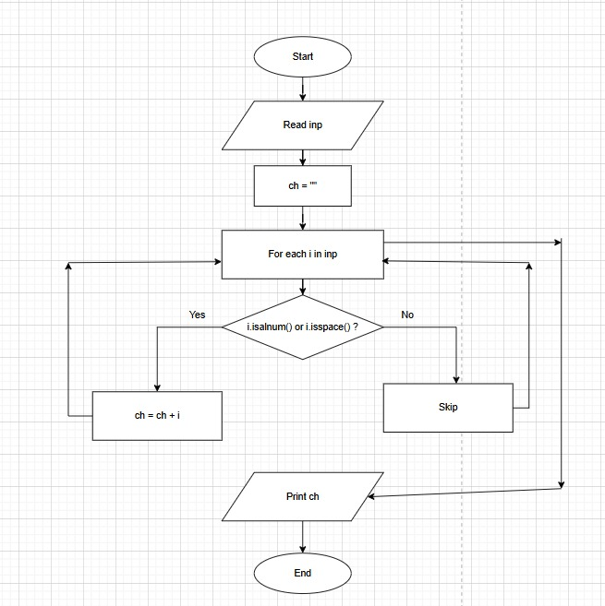

CODETANTRA:
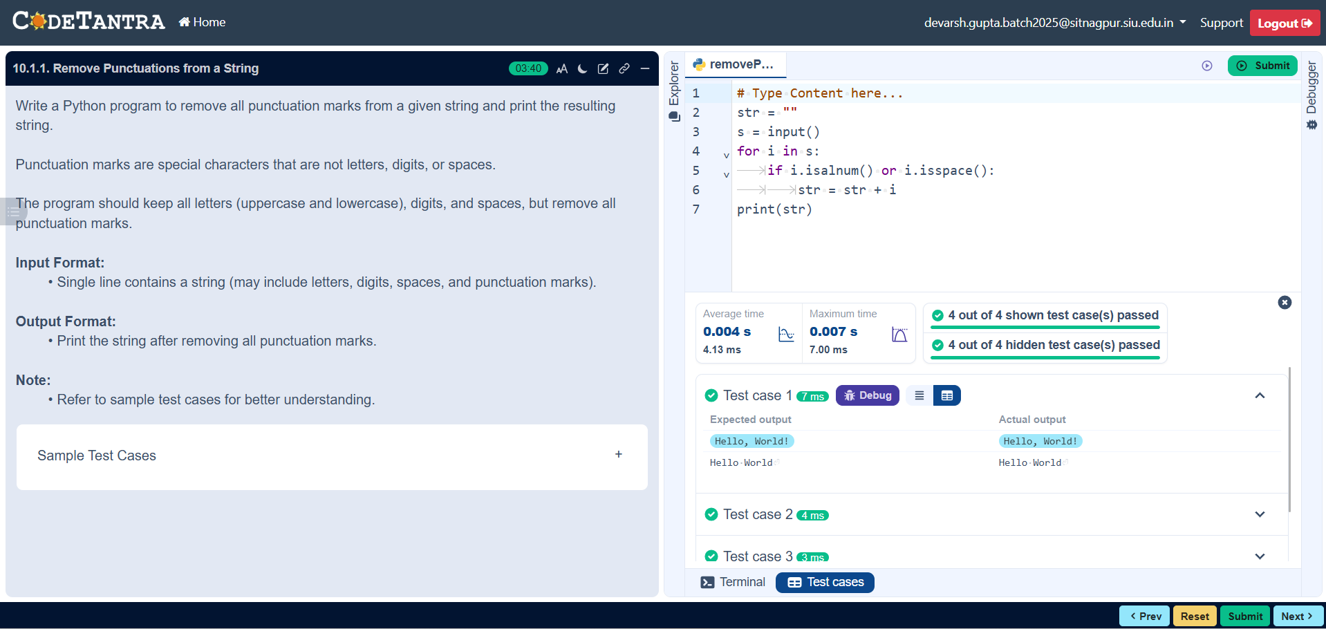
10.1.2//Reverse a string
Ans: ALGORITHM:
Step 1: Start
Step 2: Define function reverse_string(str1)
Step 3: Initialize empty string res = ""
Step 4: Find length of string
ln = len(str1)
Step 5: Set loop from ln-1 to 0
Step 6: Append each character to res
res = res + str1[i]
Step 7: Repeat Step 6 until loop ends
Step 8: Return res
Step 9: Read input string from user
Step 10: Call function reverse_string(user_input)
Step 11: Store result in variable result
Step 12: Print Original String
Step 13: Print Reversed String
Step 14: Stop

FLOWCHART:

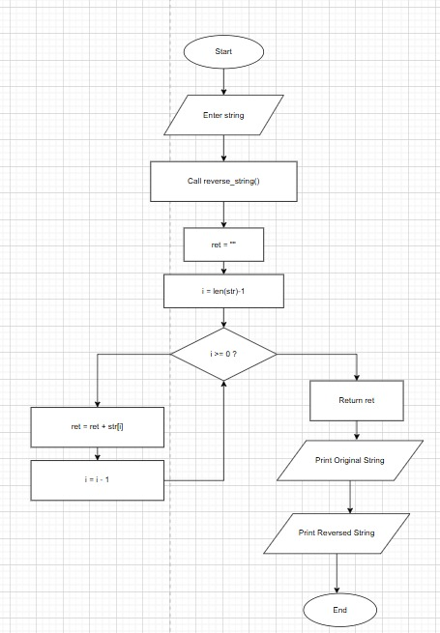
CODETANTRA:
